# ***CURRICULUM VITA***

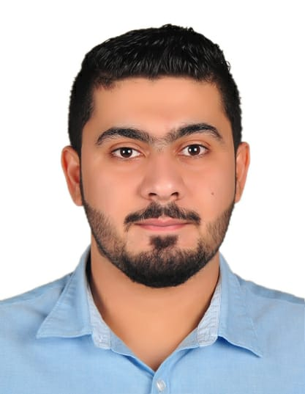

# **Name: Mohamed Maki Mohamed Al Makana**

# **Contact Number: 38353985 - 39639586**

**E-mail: almakana97@gmail.com**

**Address: House:572-- Road:218-- Block: 602**

**Sitra, Bahrain**

**Personal Information:**

* **Date of Birth: 5 Dec,1997**
* **Gender**:  **Male**

### **Nationality**: **Bahraini**

* **CPR Number: 971201935**
* **Marital Status: Single**

**Educational Qualification:**

|  |  |  |
| --- | --- | --- |
| **Degree** | **Date** | **Educational Institute** |
| **Bachelor of Commerce** | **2015- 2018** | **Bharati vidapeeth Deemed University , India** |

**Skills:**

* Microsoft office applications (Excel, Word & Power point).
* Languages (Arabic - English)
* Capable of learning new material very quickly.
* Very independent & responsible.
* Work extremely well with others.
* Ability to making good relation with others.

**Interest, Hobbies & Activities:**

Sports, reading, internet and watching movies

**References:** Available upon request.

# 